Riphah International University
I-14 Main Campus
Faculty of Computing
Class: | SPRING-2026  CS-6-1 | Subject: | Artificial Intelligence
Course Code: | CS 3703 | Lab Instructor: | Junaid Khan

-------------------- LAB 06--------------------

Learning Objective:
- Tic Tac Toe
- Lab Task.

Tic Tac Toe - Evaluation Function
In the real world when we are creating a program to play Tic-Tac-Toe, Chess, Backgammon, etc.
We need to implement a function that calculates the value of the board depending on the placement of pieces on the board. This function is often known as Evaluation Function or a Heuristic function.

The evaluation function is unique for every type of game.
The basic idea behind the evaluation function is to give a high value for a board if maximar's turn or low value for the board if minimizer's turn.

Let us consider X as the maximizer and O as the minimizer.
Let us build evaluation function:
- If X wins on the board we give it a positive value of +10.
- If O wins on the board we give it a negative value of -10
- If no one has won or the game results in a draw then we give a value of +0
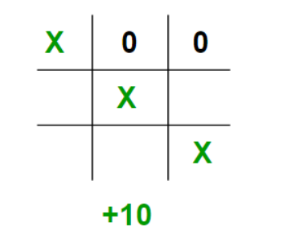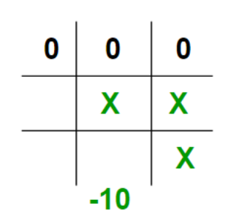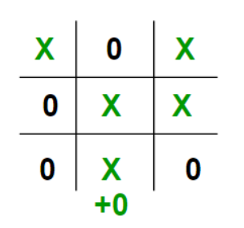

We could have chosen any positive / negative value other than 10. For the sake of simplicity we
chose 10, we shall use lower case 'x' lower case 'o' to represent the players and an underscore '_' to represent a blank space on the board.

If we represent our board as a 3×3 2D character matrix, like char board[3][3];
We are using list.
Then we have to check each row, each column and the diagonals to check if either of the players have gotten 3 in a row.

Implementing for a sample board

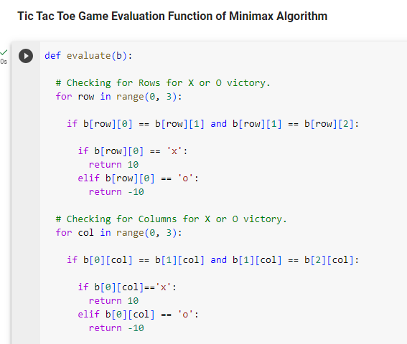

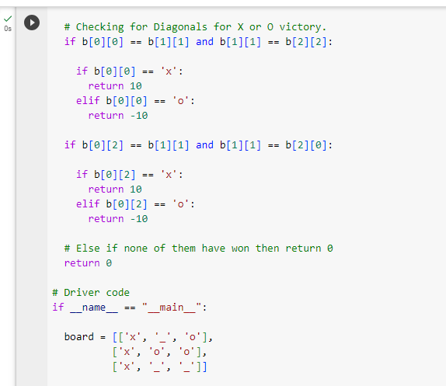

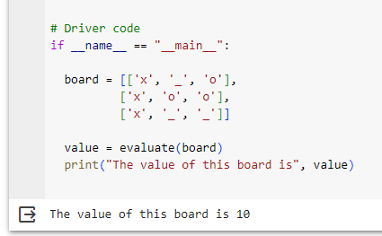

Task:
- Update the board and analyze the code, upload lab activity (Tic Tac Toe) on moellim.
- With the help of python libraries, implement the above task in GUI.

